

School of Applied Sciences  
Bachelor of Science in Computing

**COMP321-321 ISI Report**

Academic Year 2020/21   
2nd semester

|  |  |
| --- | --- |
| Online Shopping Mall Project | |
|  |  |
| Project number: | Group 5 |
| Team members: | Chi, Dend Yong Zhi (P-16-0498-1) |
|  | Ben, Leong Hang Pan (P-18-0187-5) |
|  | Tony, Tou Kin Hong (P-18-0191-5) |
| Supervisor: | Ms. Calana Chan |
| Assessor: |  |
| Submission Date: | April 30, 2021 |

**Contents**

1 Introduction 4

1.1 Overview 4

1.2 Objectives 5

1.3 Risk Assessment 7

1.3.1 Plans risk description, preventive measures and emergency response plan 8

1.3.2 Reassess the risks after applying the emergency response plan 10

2.Background and Related Work 11

3.System Design 11

3.1 Data Modelling 12

3.2 Data Modelling 21

6. Conclusion and Further Work 21

Reference 22

**List of tables**

Table 1: Table of Risk Ranking List 7

Table 2: Table of risk ranking list after applying the emergency response plan 10

**List of figures**

Figure 1: The impact and possibility of risk 8

Figure 2: Impact and risk probability after reassessment 11

Figure 3: Entity Relationship Diagram (After Normalization) 15

# Introduction

This section covers an overview report of the current Macao market, and we will describe the objectives and plans of the project. Finally, the risk assessment and solution are proposed.

## Overview

With the continuous progress of science and technology, mobile phones have become an indispensable technology product in human life. According to The Internet Usage Trends in Macau conducted in 2020 by The Macao Association for Internet Research, the average time spent on The Internet in Macao is 4 hours per day, and the penetration rate of mobile phones is 94%, while the figure was only 46% in 2011 [1], which proves that mobile phones are becoming more and more popular. People tend to change their mobile phones more frequently. To follow technology development, users need a new phone to get the most convenient and latest functions.

In addition, shopping on the Internet has also become common because the Internet touches almost every corner around us. Customers can buy products anytime, anywhere through a browser on a PC or smartphone. The vendor can also manage products or process orders online. The perfect market environment combined with advanced technology provides excellent retail industry opportunities. Especially in Macao, online sales can significantly reduce the cost of rent. Therefore, our project’s goal is to establish a shopping platform for selling mobile phones. We provide various functions that consumers need. For example, a consumer can add a product to a shopping cart before making a purchase and track the status of the order. Vendors can also manage orders and check fund transfer.

## Objectives

The main goal is to build an online shopping centre system, enabling customers to browse, select and purchase products in the mall, and vendors to manage, maintain and process the entire online shopping system.

The section below illustrates the 40 requirements which will be implemented from 8 aspects.

1. **[T1] Display product list**

Similar to most online shopping system, we design a list of products for customers to browse through. A thumbnail image of the product is displayed in the list. Customers can search a product by keywords, sort the product list by price and filter products by brand.

1. **[T2] User account Management function**

According to the requirements, users need to log in to an account when purchasing goods. Users without an account need to fill in the basic information for registration (user name, password, email, and address), and then log in to the system to purchase products. For security reasons, the customer's password is hashed and stored in the database.

1. **[T3] Product Page**

By clicking on a specific product in the product list, customers can will be redirected to the product details page. Users can view more information about the product on the product details page. The website will display detailed pictures on this page to provide users with more details of the product. Customers can add products to their shopping cart by clicking a button.

1. **[T4] Shopping cart**

The shopping cart function is implemented in the system. Users can add multiple products to the shopping cart before making the purchase. In the shopping cart, the customer can modify each product's quantity, remove specific products, change or add a shipping address, and check out to make a purchase order.

1. **[T5] Purchase Tracking**

In this project, customers can view their past and current purchase orders. Customers can view these orders in the order list. Clicking on order takes the customer to the order details page to see more information. The customer can cancel the order before shipping on the order details page.

1. **[T6] Management product features**

The system also provides some functions for vendors to manage their products. Vendors can create new products, browse each product's information, modify the information and pictures of existing products, and delete certain products.

1. **[T7] Order Processing**

The vendor can also process orders through the system. The order list provides all the order records of the customers. Vendors can filter these orders based on their status. By clicking on an order in the order list, the vendor can go to the details page for a particular order. The vendor can send the unshipped order, hold the order, and cancel the order before it is shipped on the details page.

1. **[T8] Advanced Function**

In order to improve the user experience, the project has some advanced features. For example, customers can rate and comment on products. They can also quickly know which products are hot-selling and out-of-stock products for vendors. The notification function allows customers to see the status of the order soon.

## Risk Assessment

A stable online mall system requires a comprehensive risk assessment and an effective emergency plan. The major threats to the project and their probabilities are evaluated by priority in Table 1. Figure 2 shows the impact and probability of risk.

Table 1: Table of Risk Ranking List

|  |  |
| --- | --- |
| Priority | Risk Identifier and Description |
| Risk 1 | Server side data inconsistence |
| Risk 2 | Server overloads |
| Risk 3 | Server stops working (Hardware Failure) |
| Risk 4 | Packet injection |
| Risk 5 | SQL injection |
| Priority 1 is the highest priority | |

|  |  |  |  |
| --- | --- | --- | --- |
| Impact  Probability | Low | Medium | High |
| Low |  | * Server overloads | * Server hardware failures. * SQL injection |
| Medium |  |  | * Packet injection |
| High | * Server side data inconsistency |  |  |

Figure 1: The impact and possibility of risk

### 1.3.1 Risk description, preventive measures and emergency response plan

**Risk 1: Server-side data inconsistence**

Data inconsistency happen when multiple tables within a database deal with the same data but may receive it from different inputs.

**Precaution:** Strictly set the database format, using dual data validation, that is, the user input with a front-end data validation, when sent back to the server, data validation is done again, to ensure the accuracy of the data.

**Solution:** Clarity is the best way to resolve data inconsistency, Besides, it is also crucial to avoid duplication of data as much as possible. For example, the database should use the foreign key to obtain data to avoid repeated data input.

**Risk 2: Server overloads**

Server overload means that the request exceeds the load range of the server. There are two kinds of situations leading to server overload. The first one is too many normal users, leading to server overload; the second one is malicious attacks such as DDoS.

**Precaution:** This web hosting centre has a traffic monitoring service. If the traffic exceeds a specific range, it will issue an alert.

**Solution:** If there is a need, we can always upgrade the service, requiring more space and network speed. The website can also intercept DDoS and other consumption of network resources of the attack.

**Risk 3: Server stops working**

Server hardware may go wrong after millions of calculations and high temperatures, and a small error can cause a machine to stop running.

**Solution:** It is described in detail in the web hosting contract that there is a guarantee that our servers work 99.9% of the time. All the servers are monitored 24/7 by an expert team of Admins and Engineers.

**Risk 4: Packet injection**

Packet injection in computer networking is the process of interfering with an established network connection using constructed packets to appear as part of the standard communication stream.

**Solution:** Our website has applied for SSL credentials, ensuring the packet's encryption and preventing the package from being intercepted and modified.

**Risk 5: SQL injection**

SQL injection is a security vulnerability in the application program and database layer. SQL instructions are included in the string input by the user. If the character check is ignored in the poorly designed program, the system will execute the user's SQL code input.

**Precaution:** To prevent SQL injection, we should check the user input data at the front end, and if the user enters SQL code, we forbid it from being sent to the server.

**Solution:** We can solve SQL injection by verifying input data and managing database permissions. For example, some pages only need the function of select, so we only allow select permissions to avoid using full privileges.

### 1.3.2 Reassess the risks after applying the emergency response plan

When emergency response plan is applied, two risks reduce the probability of occurrence. Accordingly, the new risk prioritization table is shown below (see Table 2), and the impact and probability of risk are shown in Figure 2.

Table 2: Table of risk ranking list after applying the emergency response plan

|  |  |
| --- | --- |
| Priority | Risk Identifier and Description |
| Risk 1 | Server-side data inconsistence |
| Risk 2 | Server overloads |
| Risk 3 | The server stops working (Hardware Failure) |
| Risk 4 | Packet injection |
| Risk 5 | SQL injection |
| Priority 1 is the highest priority | |

|  |  |  |  |
| --- | --- | --- | --- |
| Impact  Probability | Low | Medium | High |
| Low | * Server side data inconsistency | * Server overloads | * Server hardware failures. * SQL injection * Packet injection |
| Medium |  |  |  |
| High |  |  |  |

Figure 2: Impact and risk probability after reassessment

The report is about our online shopping mall. Chapter 1 gives a brief introduction to the whole project. In the Chapter 2 of this report, we will cover the background of our project and some of the rival research. Chapter 3, system design, namely data modelling and dynamic modelling. Chapter 4, we will mention the implementation of the system. Chapter 5, the end of the report will include the results and discussion by presenting some project results and testing the system. Chapter 6, we will have a conclusion and further work about ours project.

# 2.Background and Related Work

Electronic commerce (e-commerce) is the activity of electronically buying or selling of products on online services or over the Internet. The common features of e-commerce websites and the background of our project are introduced in the background section. In addition, the comparison between Taobao, Amazon and our works are discussed in the related work section.

**2.1 Background**

With the development of science and technology, e-commerce has become a part of daily life, many people like to use e-commerce websites to do shopping online now. People just need to place an order on some e-commerce platforms or websites, and then they can wait for the goods to be delivered. This is a very convenient way of shopping, especially at special times. For example, during the period of COVID-19, people are going out less often, shopping outside becomes difficult and dangerous. Using e-commerce platforms allows people to shop at home, which reduces the risk of COVID-19 infection, and to shop normally.

There are some common features of e-commerce web sites:

1. Customer login system: The user should create an account and login into the system.
2. Shopping cart: User can add their favourite items to the shopping cart.
3. Search bar: The user can use the search bar to enter the keyword to search for the items they want.
4. Online payment system: The user can complete transactions through online payment.
5. Classification of goods: On the homepage of the website, there are some product categories for users to choose from.
6. Consumer reviews on products: This part let the customers read, rate and give reviews to products.

Every year new smartphones are being launched and smartphones have become important things in people's lives. Some people may want to change smartphones frequently with the latest version of the phone, and some people may change smartphones after a long period of time, so we want to build an e-commerce platform for smartphone transactions.

**2.2 Related work**

Taobao [2] is a Chinese online shopping website and is mainly used by users in Asia. It is one of the world’s biggest e-commerce websites. Amazon [3] is an American multinational online shopping website which is used by users all over the world. They are both world-renowned e-commerce platforms, and they have all the common features of e-commerce website, so we will compare them in several different ways.

Customer service:

On Taobao, buyers can contact the store through Aliwangwang, and they will get feedback very quickly, which is very convenient for buyers. On the contrary, in Amazon, the buyer can only ask the seller by leaving a message at the bottom of the product, but the seller may not reply in time, which is inconvenient for the buyer.

Goods recommendation:

On Amazon, when we look at a good, the bottom of the page will have a bar to tell us what related items other customers also browsed/bought. However, in Taobao, the system will only show system recommendations at the bottom of the page.

Language options:

Since Amazon's customer base is people from all over the world, it has a language switching function, making it easy for people from different regions to browse. Taobao's main customer base is Chinese, so it only has a Chinese-language interface but no other language interface, which is very inconvenient for foreigners living in Asia.

Category filter:

At Amazon, when a user has finished searching for a product, the filter is on the left-hand side of the screen. However, in Taobao, after the user has searched the product, the filter will be at the top of the interface.

In conclusion, although Taobao and Amazon are popular e-commerce sites, they also have a number of differences in some functions. The reason for these differences may be that the two e-commerce websites have targeted different customers. To make our work better, we think they have their own advantages and we can learn something from their features.

In our system, we will put the filter on the left-hand side, we think the filter is placed on the left-hand side can make the interface look cleaner and better organized.

# 3.System Design

To implement an e-business system, a good database structure and some special considerations must be implemented. The two phases of the system design, an overview of the overall database structure, details and special considerations will be described below, and a detailed description of the system's dynamic data exchange methods between the different parts of the system will be covered.

## 3.1 Data Modelling

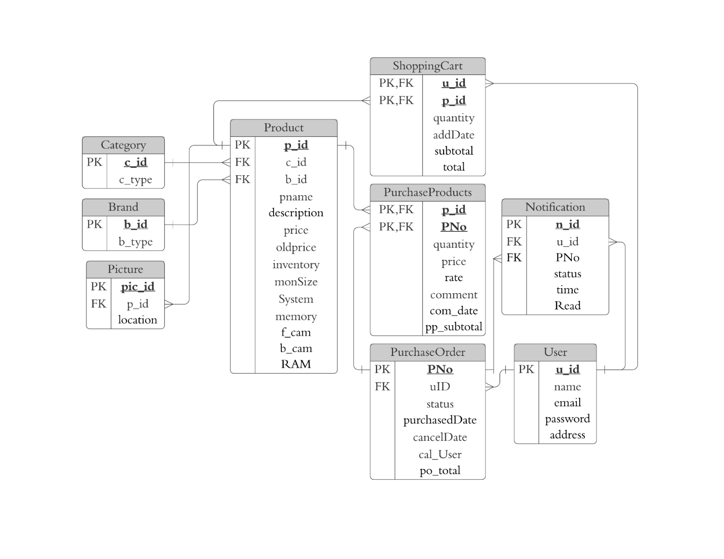The following figure is a standardized ER diagram of the system. There are nine entities in the database modelling.

Figure 3: Entity Relationship Diagram (After Normalization)

Entity Product represents the products (smart phones) with a unique product id and some detail attributes( smartphone name, description, price, inventory, monitor size, system and images) which are required in the purchase process. Since a product may have many detailed pictures, there is a named Picture entity to store information about these detail pictures. It contains foreign keys, indicating which product it belongs to, and indexes, which indicate the order of the images. The database we used in this system is MYSQL, it cannot store any format of image files, so the path of the image is stored in the database rather than the image file. Entity Category is created to save different smartphones categories. Entity Brand is created to save different smartphones brands.

To implement the purchase order tracking functions, the PurchaseOrder entity is designed to store the data of every purchase order. It includes the user's id, status, date of purchase, cancel date and user (if the order is cancelled), purchase amount total. Since an order may have multiple products, so a PurchaseProducts entity is created to store information about each product in a particular purchase order. The PurchaseProducts entity contains a PNo as a foreign key for a particular order, and a pid as a foreign key for a particular product. It also contains price, review, comment date, price, and subtotal amount of the product. Since the price of the product might be changed later, the price is also an attribute in the table, which is used to record the fees paid when the customer checks out.

The online mall system has a shopping cart function, therefore the entity ShoppingCart is created to store product information in a specific user's shopping cart. The entity stores a uid and pid to indicate the customer to which it belongs, the number of products, the date the product was added to the cart, the price of the product, and the foreign key for that particular product. The reason for storing only the product ID is that the price of each product may change before the user checks out, so only one reference is stored in the ShoppingCart entity to maintain overall system consistency.

Customers are represented by Users entity. It contains basic information of customers, for example, user name, email, password and address.

To notify a customer about the status of the item purchased, entity Notification is used to create and save a notification with nid. This entity contains uid, PNo, status, time of the notification was created, and whether the notification is read or unread.

Presented below is our database data dictionary which will give further details on the domain of the attribute:

“Product” is an entity that contains all product’s information. p_id of “Product” is referenced by two entities called “ShoppingCart”, “PurchaseProducts”.

|  |  |  |  |
| --- | --- | --- | --- |
| **Product** | | | |
| Attributes | Description | Data Type(Remarles) | Remind |
| p_id  c_id  b_id  pname  description  price  oldprice  inventory  monSize  System  memory  f_cam  b_cam  RAM | Uniquely identifies the product  To identify the category it belongs  To identify the brand it belongs  Name of product  Short description of product  Current product price  Original price of product  Current product quantity of product  Inches of the product screen  The system of product  Memory size of the product(Gigabyte)  Product front camera pixel (Million)  Product back camera pixel (Million)  The capacity of product random access memory(Gigabyte) | Integer(8)  Integer(8)  Integer(8)  Text(255)  Text(255)  Double  Double  Integer(5)  Double(8,2)  Text  Integer(3)  Integer(5)  Integer(5)  Integer(3) | Primary Key  Foreign Key  Foreign Key |

“User” is an entity that contains all user data. u_id of “User” is referenced by three entities, namely “ShoppingCart”, “Notification” and “PurchaseOrder”.

|  |  |  |  |
| --- | --- | --- | --- |
| **User** | | | |
| Attributes | Description | Data Type(Length, Decimal Point) | Remind |
| u_id  name  email  password  address | Uniquely identifies the customer  The name of the user  The email address of the user  The password of the user’s account  The shipping address of the user | Integer(8)  Text(255)  Text(255)  Text(255)  Text | Primary Key |

“Category” is an entity that contains all the categories of products. c_id of “Category” is referenced by the entity called “Product”.

|  |  |  |  |
| --- | --- | --- | --- |
| **Category** | | | |
| Attributes | Description | Data Type(Length, Decimal Point) | Remind |
| c_id  c_type | Uniquely identifies the category  The name of type | Integer(8)  Text | Primary Key |

“Brand” is an entity that contains all the brands of products. b_id of “Brand” is referenced by the entity called “Product”.

|  |  |  |  |
| --- | --- | --- | --- |
| **Brand** | | | |
| Attributes | Description | Data Type(Length, Decimal Point) | Remind |
| b_id  b_type | Uniquely identifies the brand  The name of brand | Integer(8)  Text | Primary Key |

“Picture” is an entity that contain the path of all product pictures.

|  |  |  |  |
| --- | --- | --- | --- |
| **Picture** | | | |
| Attributes | Description | Data Type(Length, Decimal Point) | Remind |
| pic_id  p_id  location | Uniquely identifies the picture  To identify the product  The location of picture | Integer(8)  Integer(8)  Text | Primary Key  Foreign Key |

“PurchaseOrder” is an entity that records all the orders of the system. PNo of “PurchaseOrder” is referenced by two entities called “PurchaseProducts” and “Notification”.

|  |  |  |  |
| --- | --- | --- | --- |
| **PurchaseOrder** | | | |
| Attributes | Description | Data Type(Length, Decimal Point) | Remind |
| PNo  uID  status  purchasedDate  cancelDate  cal_User  po_total | Uniquely identifies the purchase order  To identify the user it belongs  The product’s delivery status  The date of purchase  The date that the product being cancel by customer or vender.  The person who deleted the Order.  The total price of purchase order | Integer(8)  Integer(8)  Tinyint(1)  Date  Date  Text  Double(8,2) | Primary Key  Foreign Key  [1:Pending  2:Shipped  3:Canceled  4:Hold]  [Can be null]  [Can be null]  [Can be null] |

“p_id” and “PNO” are the composite primary key in “PurchaseProducts”, that records the corresponding quantity of purchased products and other details.

|  |  |  |  |
| --- | --- | --- | --- |
| **PurchaseProducts** | | | |
| Attributes | Description | Data Type(Length, Decimal Point) | Remind |
| p_id  PNo  quantity  price  rate  comment  com_date  pp_subtotal | To identify the product it belong  To identify the purchase order it belong  The number of products purchased  The purchase price of the product  The rating of the product  The comment of Customer reviews of the product  The date of comment  The subtotal price of purchase products | Integer(8)  Integer(8)  Integer(6)  Double  Double  Text  Date  Double(8,2) | Primary Key  Foreign Key  Primary Key  Foreign Key  [Can be null] |

"ShoppingCart" is an entity that records the products each user wishes to purchase in the ShoppingCart.

|  |  |  |  |
| --- | --- | --- | --- |
| **ShoppingCart** | | | |
| Attributes | Description | Data Type(Length, Decimal Point) | Remind |
| u_id  p_id  quantity  addDate  subtotal  total | To identifies the user it belong  Uniquely identifies the product  The number of the purchased product in Shopping Cart  The date the user added the product to the shopping cart  The subtotal of shopping cart  The total of shopping cart | Integer(8)  Integer(8)  Integer(6)  Date  Double  Double | Primary Key Foreign Key  Primary Key Foreign Key  Derived Attribute  Derived Attribute |

"Notification" is an entity that records order status and alerts the user.

|  |  |  |  |
| --- | --- | --- | --- |
| **Notification** | | | |
| Attributes | Description | Data Type(Length, Decimal Point) | Remind |
| n_id  u_id  PNo  status  time  Read | Uniquely identifies the notification  To identifies the user it belongs  To identify the purchase order  The record of corresponding order status  (Pending or Shipped or Cancelled by vendor or cancelled by user or Hold)  The time of order status changed  Determine the notification is read by user or not | Integer(8)  Integer(8)  Integer(8)  Integer(1)  Date  Boolean | [Primary Key]  [Foreign Key]  [Foreign Key]  [1:Pending  2:Shipped  3:Canceled  4:Hold]  [0 or 1] |

## 3.2 Data Modelling

In this section, the dynamic modelling in is specified with the use of sequence diagram.

# 4. System Implementation

In this section, we introduce the architecture and functions of the online mall.

## Architecture

Online mall consists of two architectures: layered architecture and MVC model. The architecture is divided into the following two sections.

To achieve efficient, robust, and developer-friendly development, we chose some popular technologies as development tools. The database used in this system is MYSQL. The entire system is written in PHP with no framework. The whole system adopts MVC (Model - View - Controller) design mode.

## 4.1.1 Layered Architecture

Our project uses the layered architectural pattern to divide code with similar responsibilities into layers. JavaScript handles the presentation of content and interaction with users. It gets the data from Apache, use PHP and Bootstrap to receive data from the upper layer and convert it. At the back-end is the MySQL server which is used to retrieve data from the data source.

Figure 4 Website architecture

Web Browser  
HTML and JavaScript

Web Server  
Apache

Application Server  
PHP

Database  
MySQL Server

## MVC Model

Our project also uses the MVC model to separate the model, view, and controller. Speeds up our development process and provides an easy way to divide work. The architecture is shown below.

**Controller**

Handling HTTP Requests

Processing PHP Requests

Data Validations

**View**

Generating Page

Using Templates

**Model**

Database Operation

Verification

Business Processes

HTTP Request

Return Display

Send Request

Return Response

Get Data

Send

Figure 5 MVC model

## Product Search

We implement three types of search capabilities for our customers. Each user can search for products by the Product keyword. If the user uses brand or category filter, the search function will filter the product by brand or category.

The search function consists of JavaScript and PHP. JavaScript is responsible for checking whether the user has entered a keyword and clicked the search button. If it detects that the user has entered any character and clicked the search button, it will make the keyword a GET parameter. PHP is responsible for receiving Get Parameters (such as search keywords, brands, category). PHP converts these conditions into SQL queries. After filtering, users can get the products they want.

As shown in the following code, the customer and vendor search functions are very similar. The only difference is that vendors can search for products by product ID.

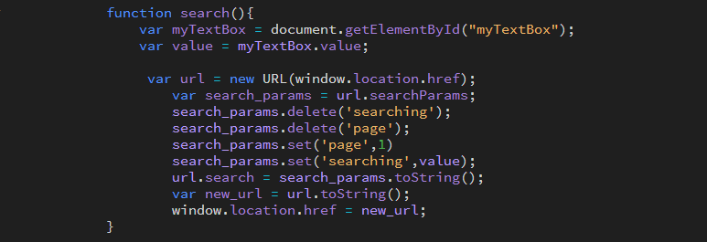

Figure 6: JavaScript Code Of Search Function

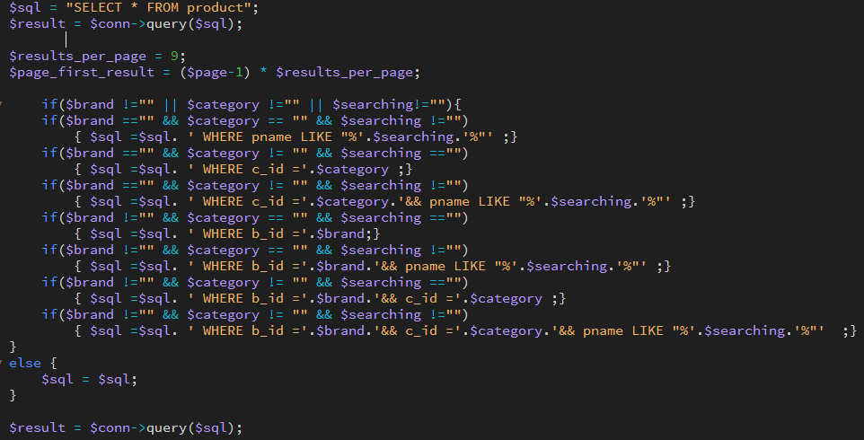

Figure 7: PHP Code of Search Function at Customer Side

Customer's search function can search for products by product keywords. In addition, it also supports brands and category of filters.

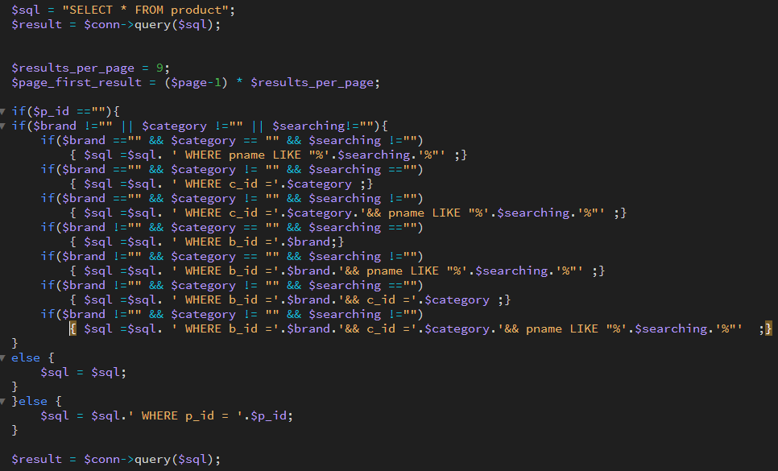

Figure 8:PHP Code of Search Function at Vendor Side

Customer's search function can search for products by product keywords and product ID. In addition, it also supports brands and category of filters.

## Image Storage and Handling

When the vendor uploads the image to the server, it assigns the image a unique id before storing it. After that, it will be stored in the root \img folder specified in photos_management.php (Figure 10). Then, website will insert the file path into the database.

For images displayed on the client, the server transfers all image paths by retrieving the image in the database. The server provides two types of users, the vendor and the customer, to view the product image and allows the vendor to edit it. Both of them can view product thumbnails in the product list page, and all of the detailed images in the product details page. In addition, vendors can delete and re-upload images in the photos management page.

This part is composed of PHP. PHP is responsible for uploading the picture back to the root directory and updating the path of the picture in database.

We divide the upload photos into three states, state one replaces the photos, the vendor can replace the old photos with the new photos . The state two, adds photos, there is no photosin the field, and the Vendor is allowed to upload a photos. State three, delete the photos , if Vendor feels the photos is not satisfied, you can delete the photos.

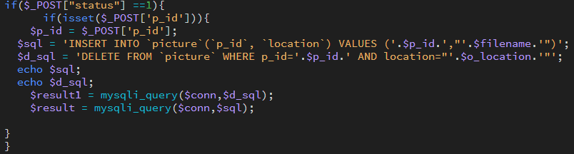

Figure 9: Code of Image Update

Since this system only allows 1-5 pictures to be uploaded. If the vendor replaces a new picture ,then the system needs to delete the previous picture.

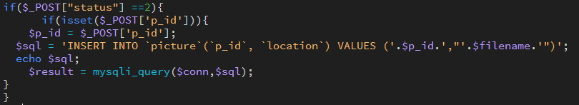

Figure 10: Code of Image Storage

Figure 10 shows how to store the image in the server. The condition indicates whether the image is empty (you can upload it if it is empty, otherwise you can only replace the image). If the conditions pass, the image will be uploaded to the server and the path will be inserted in the database. The image has an auto-incrementing number and the value of the reference product ID. The image name depends on the image name and path.

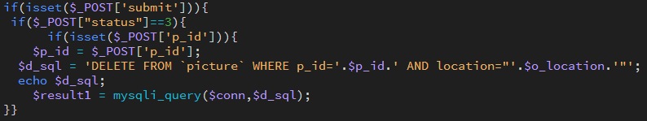

Figure 11: Code of Image Removal

The Vendor can delete the picture by pressing the delete button. When the Vendor deletes the detail image, the server supports the automatic redistribution of the order of the detail image. For example, if the Vendor deletes the product detailed information image 1 and it has 4 detailed information images, the detailed information images 2 and 3 will be automatically changed to the order of 1 and 2.

## Password Security

This part is composed of JavaScript and PHP. JavaScript is responsible for checking whether the password entered by the user meets the conditions. If it meets the conditions, it will use the post method to send it to PHP. PHP is responsible for encrypting and uploading the user's password to the database.

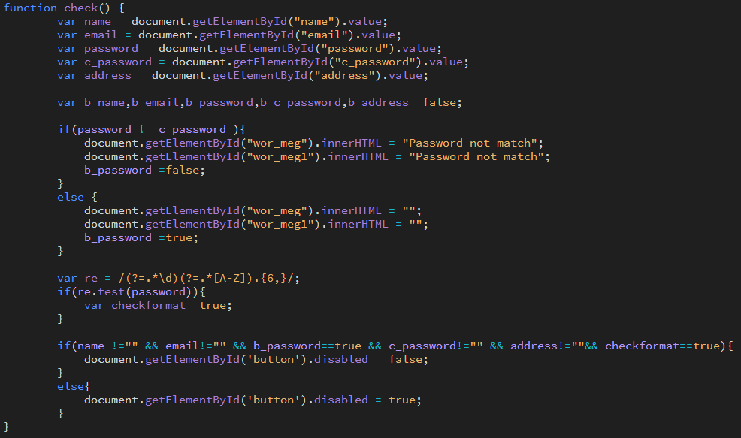

Figure 12: Code of JavaScript Check Password Regular Expression

The figure (Figure 12) shows that the password must enter at least one uppercase letter and the entire letter to satisfy the regular expression and the new password and the confirmed password must be the same.

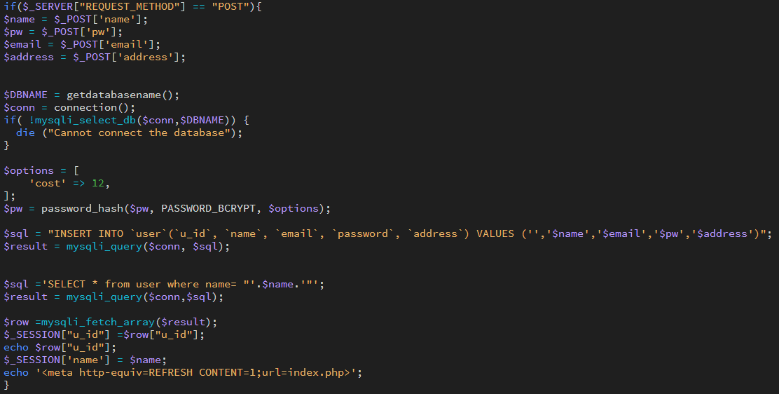

Figure 13: Code of Hash Password

because the database administrator or hacker can access the database. Therefore, the server must hash the password before storing it in the database. PHP provides a password encryption bcrypt() for hashing passwords, so we implement the hash function by using it.

PHP provides a hash function to verify user passwords. This check method will verify that a given plain text string corresponds to a given hash. If the check passes, the user will successfully log in or change the password.

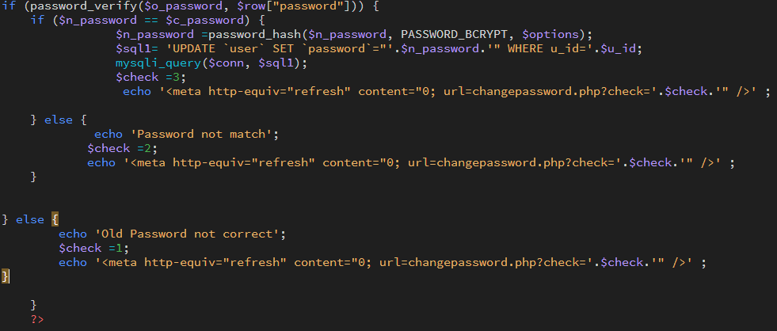

Figure 14: Code of Change Password

In the changePassword function, the server will execute a validator to verify all substituted data. After that, pass the data to the hash module and check whether the old password matches. In addition, you can check whether the new password and the repeated new password match. If all the above conditions are passed, the password will be changed.

## Purchase Order Processing

The order in the shopping mall system has 4 states: pending, shipped, cancelled and Hold. In order to facilitate management and save database storage, 4 numbers are used to represent these 4 states. 1 to 4 respectively represent pending, Shipped, cancelled and Hold. The following sections will use numbers in brackets after the status term to indicate status. (For example, pending review (1))

According to the requirements of the project specification, the order must start with the status "pending" (1). Then, the order can be cancelled(3). by the customer or vendor before shipment, otherwise it can be shipped(4). by the vendor. If the vendor cancels the order, the order status should be changed to cancelled(3). Figure 13 below shows the status change in the system. If the product is out of stock, the vendor can choose to hold(4) and keep the order, but not ship it temporarily.

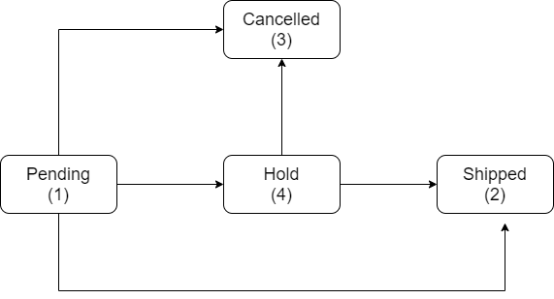

Figure 15: Purchase order status process

Vendor have 3 implemented functions to process order status: Cancel(), Hold() and Shipping(). There is also a function called Cancel() for customers to cancel orders. In this system, only 3 functions are the way to modify the order status. Before any state of the order. The system should confirm the product status, these three functions only need to check whether the current status of the order is one of the possible previous statuses of the next status.

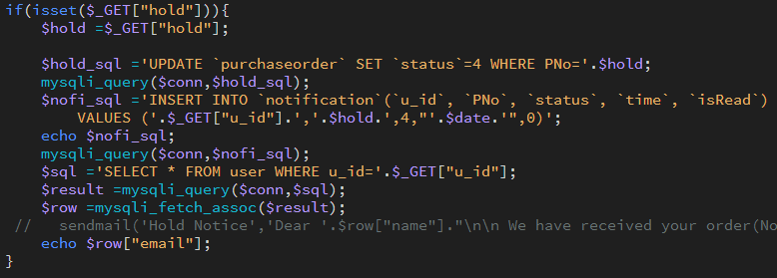

Figure 16:Code of Order Hold

The hold function transfers the state from pending (1) to hold (4). Turn to the check to check whether the order status in the code is pending (1).

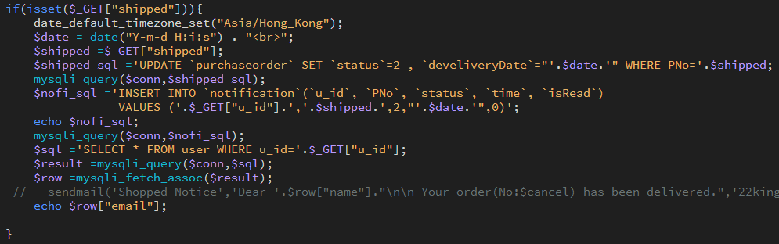

Figure 17: Code of Order Shipped

# The Shipped function transfers the order from hold (4) to shipped (2). Therefore, the code checks whether the status of the order is hold (4) before shipping.

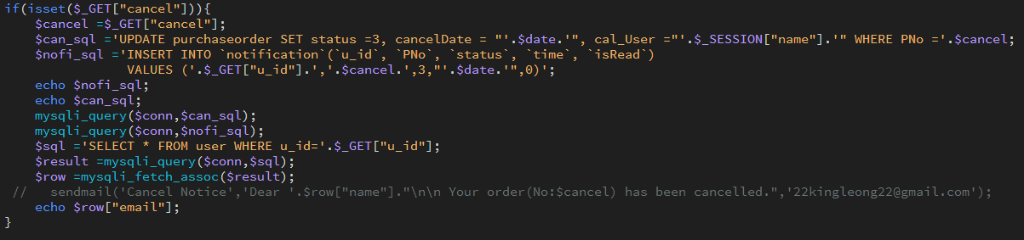

Figure 18: Code of Order Cancel

The Cancel function order shifts the order status from pending (1) or on hold (4) to cancelled (3). Therefore, the function checks whether the status of the order is pending (1) or held (4) before cancelling the order.

## Customers’ Ratings and Reviews

The shopping mall system provides customers with scoring and comment functions. After the seller ships the goods, customers can submit new ratings and reviews for each product of their order. The ratings and reviews of each customer will be stored in the PurchasedProducts database. The server will display the average rating and reviews for each product. The average rating will be stored in the product in the database. Comments will be stored in PurchasedProducts in the database. The average product rating is the sum of the ratings of each product divided by the number of customers that have been rated.

On the client side, the customer must rate the ordered products. The viewing function is optional. Customers can view their order products according to their own intentions.

The following code describes how the server processes submitted ratings and comments.

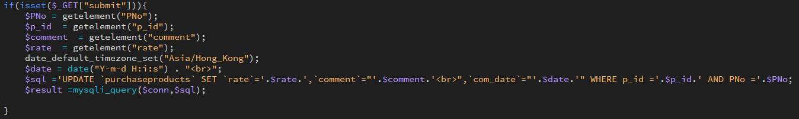

Figure 19:PHP code of Rating and Reviews

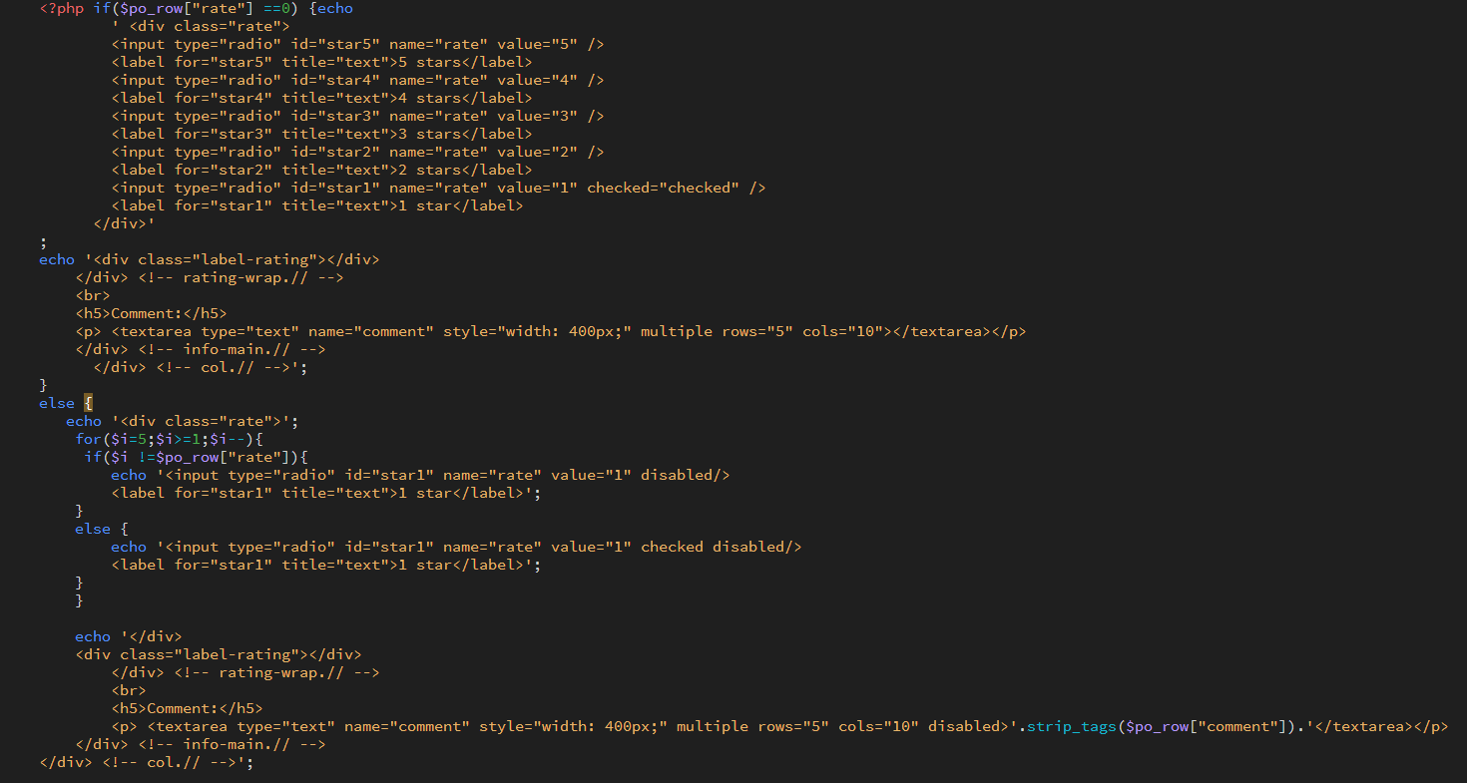

Figure 20: HTML code of Rating and Reviews

## Inventory checks

The shopping mall system has inventory checks. Before placing the customer's order, the system will check whether the product has a sufficient amount of inventory to satisfy the customer's order of product quantity. If not, the system will prohibit the supplier’s shipping order. For goods, the product inventory in the database product will use the number of products ordered by the customer in the purchased products in the database. It also updates the product inventory in the database product.

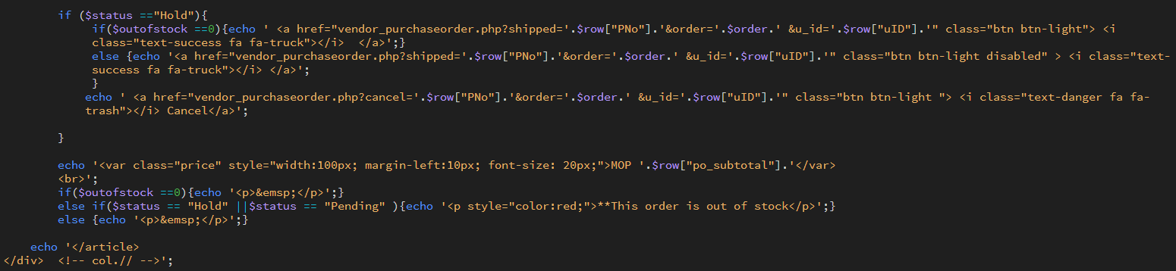

Figure 21:Code of check out of stock

## Inventory checks

The notification function is a very user-friendly function for customers. This function has been implemented in this system to support customers to track changes in the status of purchase orders. In this system, the function is real-time notification, which means that when any status of the purchase order changes, the customer will be notified immediately. The GUI of the notification function is shown in the figure below. 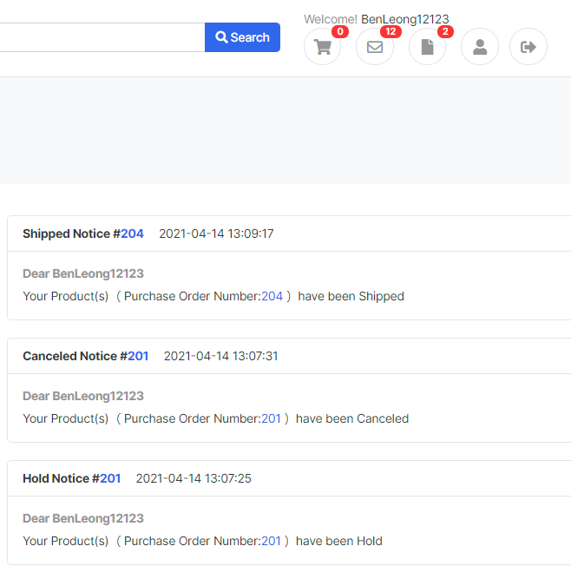

Figure 22: Graphic User Interface of Notification

This function is divided into two parts: client and server. The basic principle of this function is polling, which means that every time the client refreshes the screen, it sends a request to the server to check whether there is a new notification during this period.

The following figure informs the updated code. The main purpose of this code is to request the server to check whether there is a new notification every time the page is refreshed. If there is a new notification, the data will be updated on the client side. There are two reasons for each refresh request. First, if the request frequency is too frequent, this will affect the user experience of real-time notification. In addition, there is no need to repeatedly request the server, because the improvement of the user-friendly experience is small, and subsequent operations will put more pressure on the server.

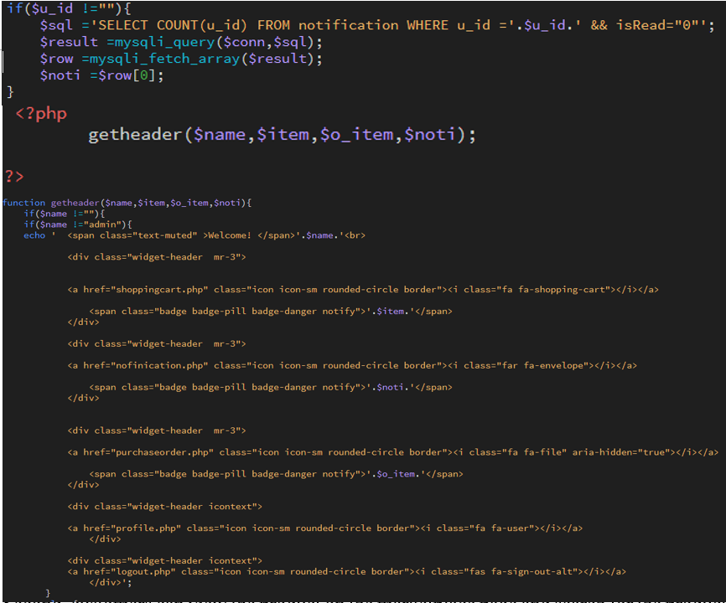

Figure 23: Graphic User Interface of Notification

# Results and Discussion

# 6. Conclusion and Further Work

In conclusion, we have successfully implemented 35 essential functions and 5 advanced functions in our project. First, our project provides a user-friendly interface for users. Second, customers can view the product on the marketplace page and search for the product by entering the product name's keyword. They can then view specific product details, including product details, promotions, customer ratings and reviews, and add the product to the shopping cart. In addition, customers can check out on the shopping cart page. When the vendor ships the product, customers will receive a notification and they may give some reviews and ratings to the product at the end of the purchase process.

Our project has a contract with a web hosting centre to ensure that the web page is secure and reliable. The first reason is that our web pages support HTTPS, a secure protocol. In addition, our website is backed up once a day to ensure security. Our project can go a long way towards ensuring the site's safety, but we also have much space for improvement, such as our project only stores data in one database at the moment. This is very dangerous in the real world because there is no data validation. If a hacker breaks into our database and maliciously changes the data, we cannot restore the database's correct data.

In the future, we look forward to enhancing the user experience, HCI, and implementing more features for the vendor and customers. First, we want to implement a new feature that allows vendors to change the order of detail images on the product edit page. In addition, we want customers to be able to categorize product tables through more attributes to meet customer needs. For example, if they're going to know our project's latest product, they can sort by the product's release date.

On the other hand, our project is aimed at the Macao market. Macao's official languages are Chinese and Portuguese, but our project only has the English version. In the future, we will develop the Chinese and Portuguese versions, collect Macao people's data, and redesign a shopping platform more catered to Macao market.

# Reference

|  |  |
| --- | --- |
| [1] | T. M. A. f. I. Research, “Internet Usage Trends in Macao,” The Macao Association for Internet Research, Macao, 2020. |
| [2] | “Taobao,” Alibaba, [Online]. Available: https://world.taobao.com/. [Accessed 23 4 2021]. |
| [3] | J. Bezos, “Amazon,” Amazon, [Online]. Available: https://www.amazon.com/ref=nav_logo. [Accessed 23 4 2021]. |